**PROPOSED SYSTEM**

In our proposed method we are using Arduino which is cheaper than raspberry pi. We will be using four sensors. Here Temperature sensor, ECG sensor, Eye blink sensor, and Glucose sensor are interfaced with Arduino. Hence we proposed an H2U Healthcare System for elderly People. In this system the patient heath care is monitored and the status is updated in system. The data is stored in the IOT. If we buy these machines individually it would cost heavy. Also it requires man power to accomplish the whole task. It has many drawbacks also. In our model the sensors that are being used are cheap. The data is directly fetched into computers which reduces the man power. In the system Temperature sensor is utilized to detect the temperature, Eye blink sensor detects when a patient is wakeful after a measurement of medication, ECG sensor is used for recording the electrical activity of the heart over a period of time using electrodes placed on the skin. Glucose sensor is used to check whether the saline bottle is empty or not. Every one of the qualities and information is sent to the Arduino. In this framework the patient heath care is checked and the information is put away in the IOT.

**Advantages:**

No man power needed.

This system will automatically transmit the values, if the patient condition increase people will get alert.

The whole project is relatively cheaper than the existing projects.

* + - * + **Block diagram**
* **Patient Section**

**Arduino**

GSM Module

**Power supply**

Eye Blink Sensor

TEMP Sensor

IOT

Glucose Sensor

ECG Sensor

* **Monitoring Section:**

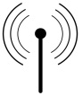

IOT

**Cloud server**

* **Hardware Requirements:**
* Arduino
* Temperature Sensor
* ECG Sensor
* Glucose Sensor
* Eye blink Sensor
* GSM
* Male to Male wire
* Male to Female wire
* **Software Requirements:**

Arduino.IDE

Visual studios

* **Languages Requirementsg:**

PC with .NET and PHP

Embedded C

**About Hardwares:**

**Arduino:**

Arduino/Genuino Uno is a microcontroller board in view of the ATmega328P . It has 14 advanced information/yield pins (of which 6 can be utilized as PWM yields), 6 simple data sources, a 16 MHz quartz precious stone, a USB association, a power jack, an ICSP header and a reset catch. It contains everything expected to bolster the microcontroller; just associate it to a PC with a USB link or power it with an AC-to-DC connector or battery to begin.. You can tinker with your UNO without agonizing excessively over accomplishing something incorrectly, most dire outcome imaginable you can trade the chip for a couple of dollars and begin once again once more.

"Uno" implies one in Italian and was denoted the arrival of Arduino Software (IDE) 1.0. The Uno board and form 1.0 of Arduino Software IDE were the reference adaptations of Arduino. The Uno board is the first in a progression of USB Arduino sheets, and the reference display for the Arduino stage; for a broad rundown of present, past or obsolete sheets see the Arduino list of sheets.

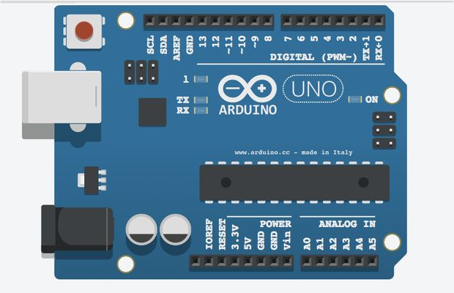

**Temperature sensor:**

Temperature is the most-measured process variable in mechanical computerization. Most usually, a temperature sensor is utilized to change over temperature incentive to an electrical esteem. Temperature Sensors are the way to peruse temperatures effectively and to control temperature in industrials applications. A large distinction can be made between temperature sensor types. Sensors differ a lot in properties such as contact-way, temperature range, calibrating method and sensing element. The temperature sensors contain a sensing element enclosed in housings of plastic or metal. With the help of conditioning circuits, the sensor will reflect the change of environmental temperature.

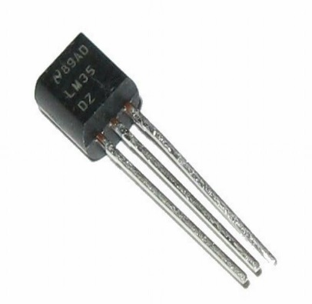

**ECG Sensor:**

Electrocardiography (ECG) is the way toward recording the electrical movement of the heart over a timeframe utilizing anodes set on the skin. These terminals recognize the minor electrical changes on the skin that emerge from the heart muscle's electrophysiologic example of depolarizing amid every pulse. It is a usually performed cardiology test.

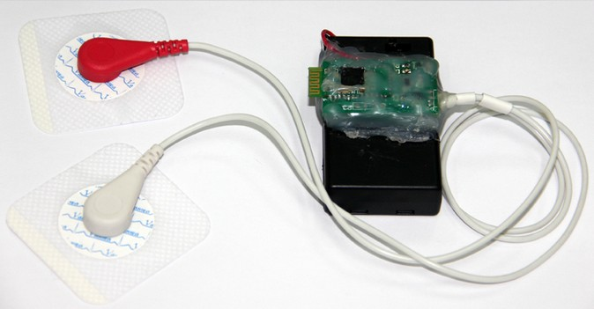

**Glucose Sensor** (moisture sensor):

This sensor is dipped into the saline bottle which is fully filled while we attach that to patient. And detects whether the saline bottle is empty or not.

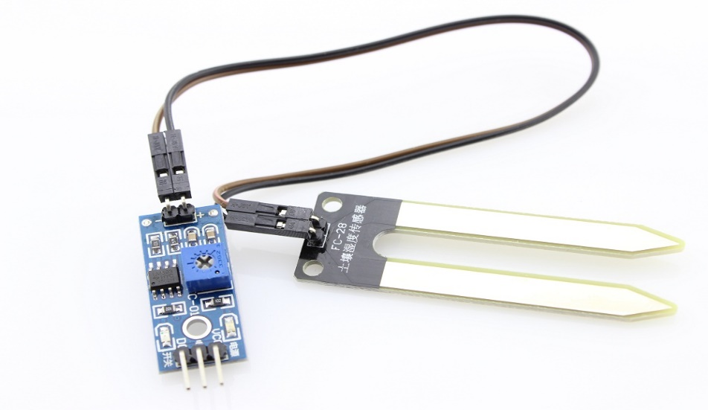

**EYE Blink Sensor:**

The eye is lit up by an IR drove, which is fueled by the +5v control supply and the reflected light is recorded by an IR photograph diode. This eye squint sensor is IR based; the variety over the eye will fluctuate according to eye flicker. The correct usefulness depends significantly on the situating and pointing of the producer and indicator as for the eye. In the event that the eye is shut means the yield is high generally yield is low. This to know the eye is shutting or opening position. This yield is provide for rationale circuit to show the alert. This can be utilized for venture includes controlling mischance because of oblivious through eye squint.

Associate directed DC control supply of 5 Volts. Dark wire is Ground, Next center wire is Brown which is yield and Red wire is certain supply. These wires are likewise set apart on PCB. To test sensor you just need control the sensor by interface two wires +5V and GND. You can leave the yield wire as it may be. At the point when Eye shut, LED is off and the yield is at 0V.Put Eye flicker sensor glass on the face inside 15mm separation, and you can see the LED squinting on each Eye flicker. The yield is dynamic high for Eye close and can be offered straightforwardly to microcontroller for interfacing applications.

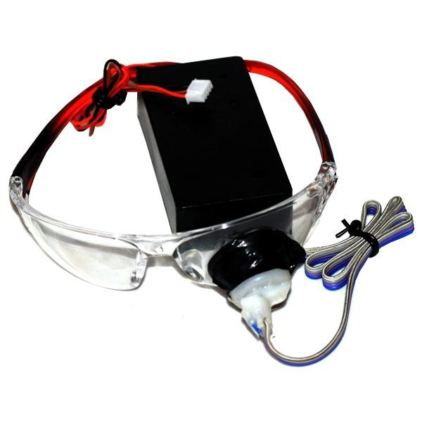

**GSM Module:**

A GSM modem is a remote modem that works with a GSM remote system. A remote modem carries on like a dial-up modem. The primary contrast between them is that a dial-up modem sends and gets information through a settled phone line while a remote modem sends and gets information through radio waves. The working of GSM modem depends on charges, the summons dependably begin with AT (which implies ATtention) and complete with a <CR> character. For instance, the dialing charge is ATD<number>; ATD3314629080; here the dialing order closes with semicolon.

The AT orders are given to the GSM modem with the assistance of PC or controller. The GSM modem is serially interfaced with the controller with the assistance of MAX 232. Here max 232 goes about as driver which changes over TTL levels to the RS 232 levels. For serial interface GSM modem requires the flag in view of RS 232 levels. The T1_OUT and R1_IN stick of MAX 232 is associated with the TX and RX stick of GSM modem.

**CIRCUIT:**

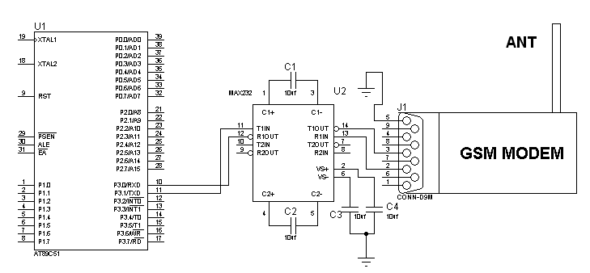

**Male to Male jumper wire:**

A jumper wire is a leading wire used to exchange electrical flags between two focuses in a circuit. The wires can either be utilized to change circuits or to analyze issues inside a circuit.

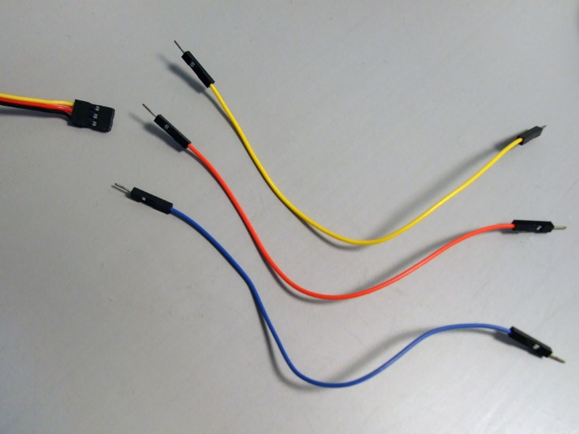

**Male to Female jumper wire:**

There is also a very useful cable that plugs into a Sensor Shield on one end, but has separate female sockets on the other end.

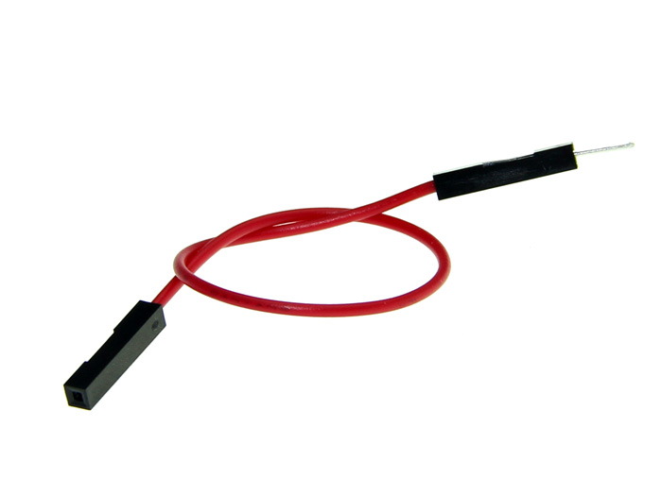

**RESULTS AND DISCUSSIONS**

After the completion and successful working of the system, the following results can be incorporated from the same.

Result from the software Arduino.IDE:-

